Network Architecture
EHC Manufacturing, LLC
Prepared By:
Marshal Simons

- Executive Summary
This report will outline the key components and theories that went into developing the network diagram in Section 2.0. Not every network will be the same, and individual consideration should be given to the most appropriate ways to ensure secure and efficient communication within the EH6 Manufacturing, LLC’s network. Through designing a secure network topology, utilizing security components and hardware to monitor traffic, and implementing best practices, the network will be best equipped to defend against malicious attacks.
This network was designed utilizing the extended star network topology to facilitate segmentation between internal subnets. Segmentation is the practice of dividing a network into separate broadcast domains to increase performance and improve security by creating rules to restrict traffic between segmented networks. The subnets were created based on department, grouping like users within the office LAN network (Sales, HR, IT, Developers, Engineers, and Executives). Additionally, the office area was separated from the manufacturing department by separate LAN interfaces on the main network router and firewall. This method allows for the creation of a ruleset that can restrict all but the necessary traffic for the company to operate.
To monitor potential network intrusion, a host-based and network-based intrusion detection system was installed. To monitor traffic as it enters the network, Suricata was installed with the Emerging Threats ruleset, which provides numerous methods to detect potentially malicious traffic. However, to monitor traffic within the network on each endpoint, Wazuh and Sysmon were installed with the SwiftOnSecurity configuration file, which will report on malicious signature-based threats and anomalous-based events. Finally, the Security Onion SIEM was installed to aggregate data received from the various security monitoring tools, providing a centralized location to monitor events in the network.
Following many of the security industry's best practices, the network was then locked down by implementing changes within the networking hardware and the creation of firewall and inter-VLAN rules. To improve the security of the Cisco switches within the network, Spiceworks.com’s Cisco Switch Best Practices Guide was implemented, which creates additional security measures and disables services that may be misused. Additionally, rules were created to restrict inter-network traffic between VLANs except for those that may require it, such as the IT department. Lastly, the creation of firewall rules on the Cisco firewall allows for the blocking of all traffic that does not explicitly follow an existing rule.
- Network Diagram
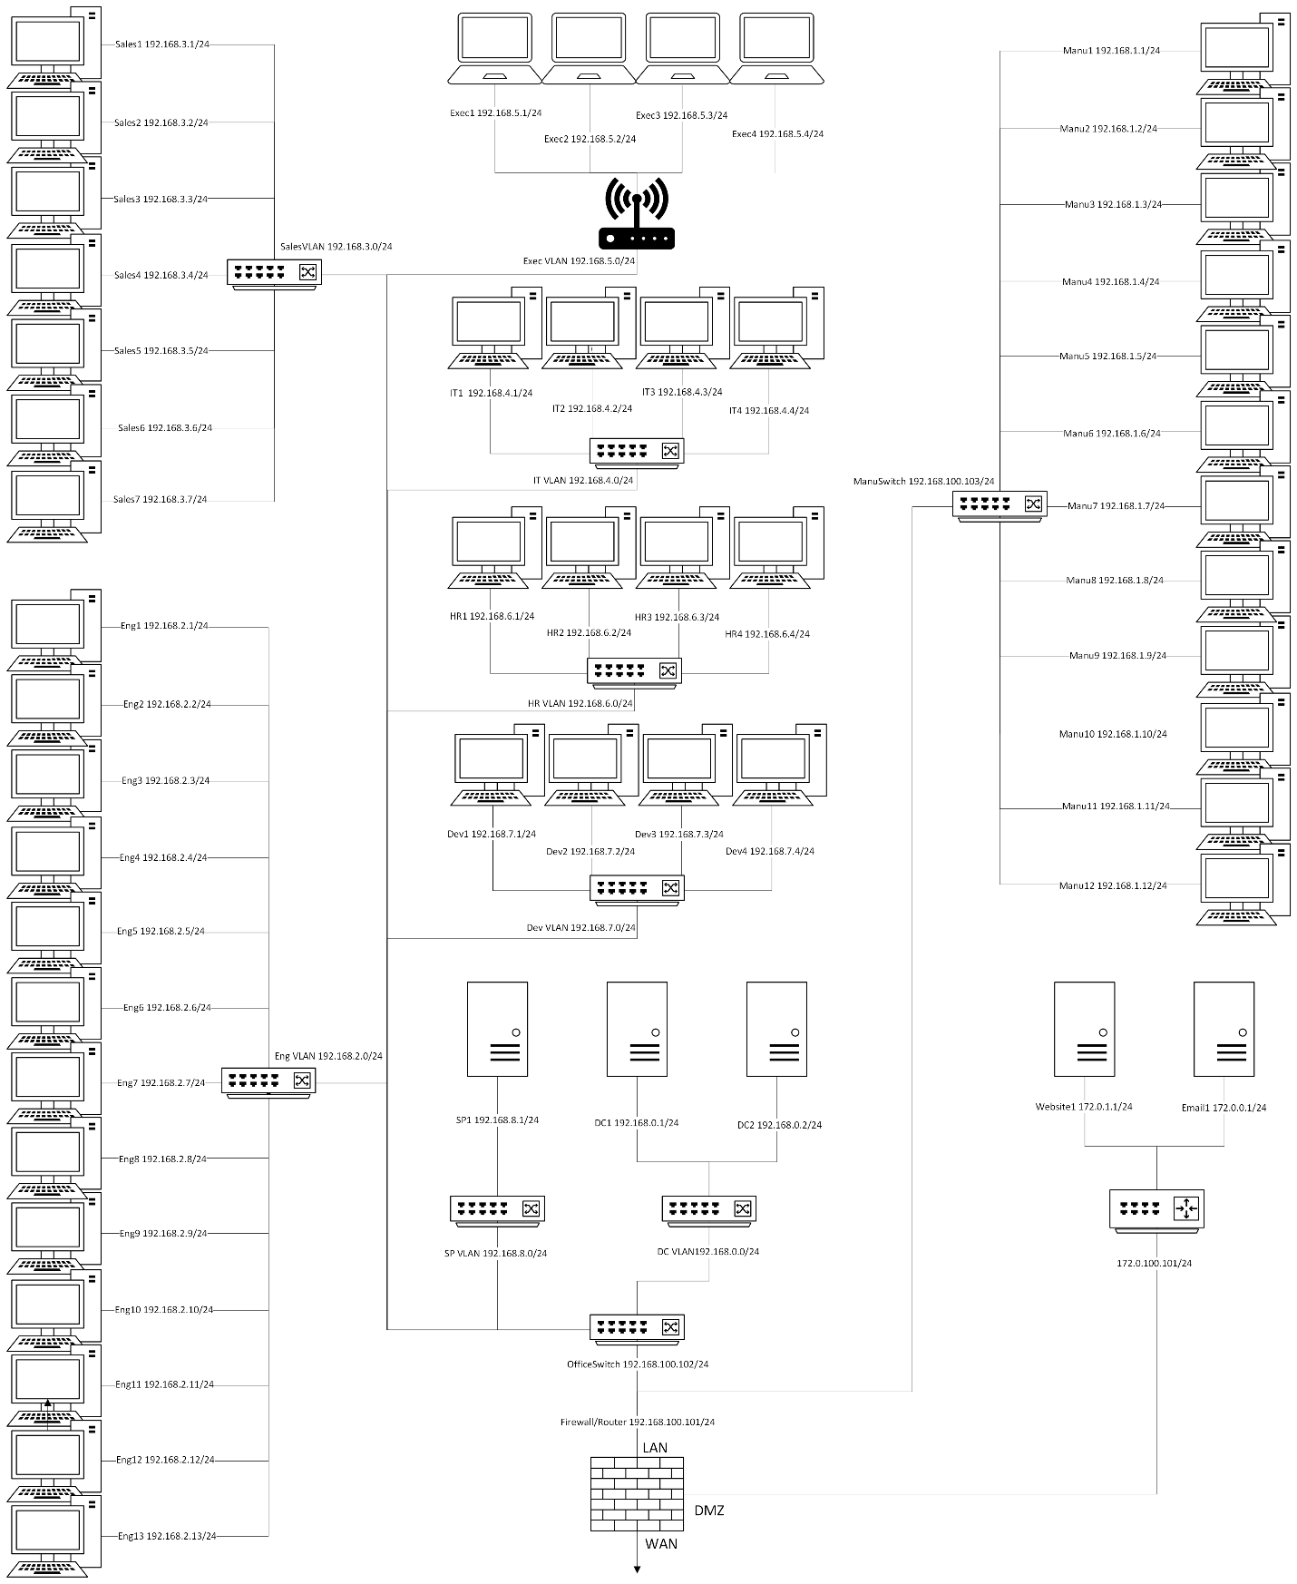
- Infrastructure and Security Components
  - Firewall: Cisco Firepower 1120
    - The Cisco Firepower 1120 was chosen to provide enough network throughput for the office space while also including security features commonly used with firewalls. The Firepower comes standard with Cisco’s Security Intelligence that covers IP, URL, and DNS threat intelligence as well as automated threat feed and IPS signature updates from Cisco Talos group. There are available addons for IPS and Malware Defense for additional costs, but will not be required for the network, as those roles will be covered by different software.
    - Cost: $2,006.99
    - Configuration:
      - WAN -> DMZ
        - Allow HTTPS to the web server
        - Allow SMTP to the mail server
      - LAN -> DMZ
        - Allow SMTP to the mail server
      - LAN -> WAN
        - Allow HTTP/HTTPS/DNS for internet access.
      - Block all traffic that does not follow a rule.
      - Enable NAT to translate LAN IPs to WAN addresses.
      - Allow necessary traffic from LAN1 (Office) to LAN2(Manufacturing).
  - Switch: Cisco Business CBS220-48T-4G
    - The CBS220-48T-4G was chosen to support the VLANs used within the office space and to be easily managed with the manufacturing switch using link aggregation. With 48/GbE ports, the switch will be able to fully support the 34 devices in the office, while also leaving room for additional devices in the future.
    - Cost: $455.99
    - Configuration: 6 VLANs for Sales, HR, IT, DevOps, Engineering, Execs. Create rules to block traffic between VLANs, with IT being an exception. Ensure rules do not block access to the file share server. Follow the Cisco Switch Best Practice Guide on startup.
  - Switch: Cisco Business CBS220-24T-4G
    - For the manufacturing department, the same version of the switch will be used, but with the 24-port model. While only needing to support 12 devices, having a device with additional ports will support further growth within the network.
    - Cost: $246.09
    - Configuration: Block all outbound traffic from LAN2 (Manufacturing). Follow the Cisco Switch Best Practice Guide on startup.
  - SIEM: Security Onion
    - Security Onion is a free and open-source SIEM that can be run from a virtual machine within the network. However, if additional performance is required, Security Onion also provides hardware appliances for a fee that can be customized to meet the network requirements. Security Onion also provides a full suite of security solutions to monitor the network down to the host level.
    - Cost: Free (Hardware appliances will require a fee).
    - Configuration: Ensure Security Onion is ingesting data from Suricata and Wazuh.
  - NIDS: Suricata
    - Suricata is Security Onion’s free network visibility tool, allowing signature-based detection using configuration files like the Emerging Threats ruleset and custom rules. Suricata also provides protocol metadata and file extraction capabilities for additional analysis.
    - Cost: Free
    - Configuration: Emerging Threats Ruleset
  - HIDS: Wazuh and Sysmon
    - Wazuh is a free and open-source host-based intrusion detection system that can read Windows Sysmon events and is incorporated directly into the Security Onion suite. The manager will require a Linux machine, but it can run on a virtual machine.
    - Cost: Free
    - Configuration: Deployment on Linux VM. Install Sysmon with the SwiftOnSecurity configuration file. Configure the Wazuh “\ossec.conf” file to read Sysmon events.
- Cost of Implementation
  - Hardware: $2,709.07
    - Firewall: $2,006.99
    - Switches: 702.08
  - Installation: 15 hours
    - Firewall: 4 hours
    - Switches: 4 hours
    - Security Onion: 1 hour
    - Suricata: 1 hour
    - Velociraptor Server: 1 hour
    - Velociraptor Client: 4 hours (5min/client)

